**OCAF Initial Application Agency Certification**



**Knowledge Base Article**

**Table of Contents**

**Overview** 3

**Initial Inquiry Acceptance** 3

**Navigating to the Application** 3

**Agency and Personnel Information** 4

**Functions** 7

**Policies** 12

**Plan** 13

**Documents** 14

**Licensing Agreement** 16

**Signature and Submission** 19

**Board President Signature and Application Submission** 20

**Overview**

This User Guide reviews the process of completing an Initial Application for Agency Certification through the Ohio Certification for Agencies and Families (OCAF) site. When the initial inquiry is completed and accepted, the user will complete their application and submit all required documentation.

**Note:** The Agency Administrator and the Board President will be required to sign this application.

**Initial Inquiry Acceptance**

Once your initial inquiry has been accepted the user will receive an email prompting the user to complete their initial application and for the Board President to create their account:

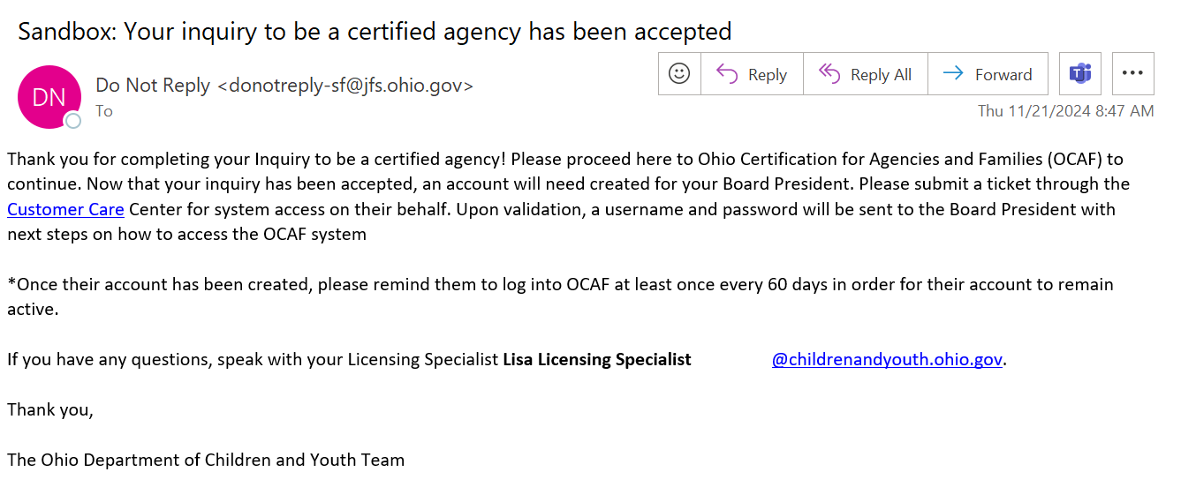

**Navigating to the Application**

1. From the **OCAF Home** tab, click **Apply for Certification**.

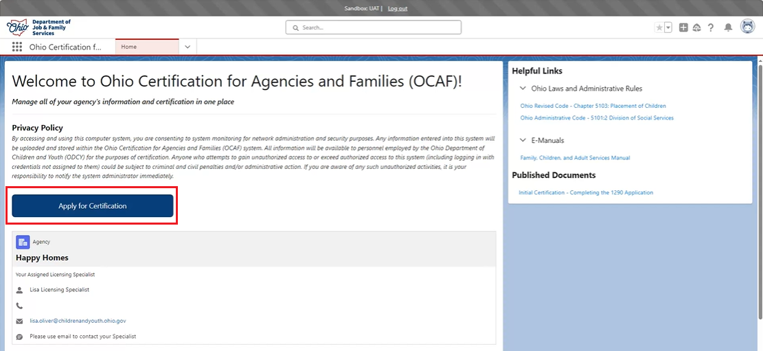

The **Application** screen displays.

**Agency and Personnel Information**

1. **Account Name** is pre-filled. Verify it is correct.
2. Make a selection from the **Type of Agency** dropdown menu.
3. **Administrative Office Street Address**, **City**, **State**, **Zip Code** and **County** are pre-filled. Verify it is correct.

**Note:** The **Administrative Office** **State** is not editable.

1. Select **Yes** or **No** for, **Is your Administrative Office’s address the same as your mailing address**.

**Note:** If **No** is selected, new Street, City, State, and Zip Code boxes will display to enter the other address.

1. Provide the **Agency Phone** number.
2. Provide the **Agency Fax Number** if applicable.

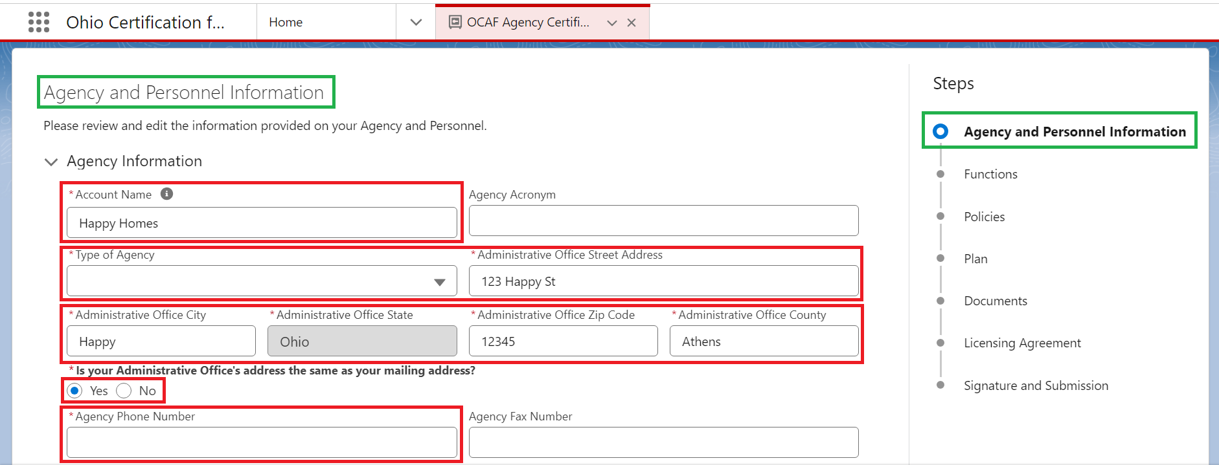

1. Make a Selection from the **Fiscal Year** dropdown menu.
2. Click the **Add New Board Member/Officer** button.

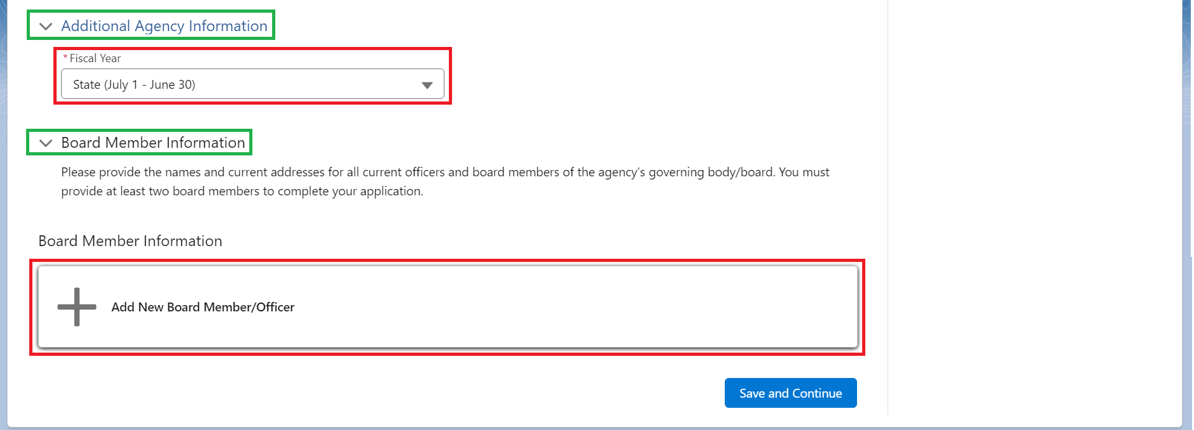

**Note:** Here is where the Agency Administrator will need to add the **Board President** and the Board President’s background checks. At least **two Board Members** are required to submit the application.

The Board Member box displays allowing the user to add Members.

1. Make a Selection from the **Board Member Type** dropdown menu. (Required)
2. Make a Selection from the **Preferred Prefix** dropdown menu. (Required)
3. Fill out the **Title**. (Required)
4. Provide **First and Last Name**. (Required)
5. Provide the **Email Address**. (Required)
6. Provide the **Phone Number**. (Required)
7. Provide the **Street, City, State and Zip Code**. (Required)
8. Select a date for **Start of Board Member Term**. (Optional)
9. Select a date for **End of Board Member Term**. (Optional)

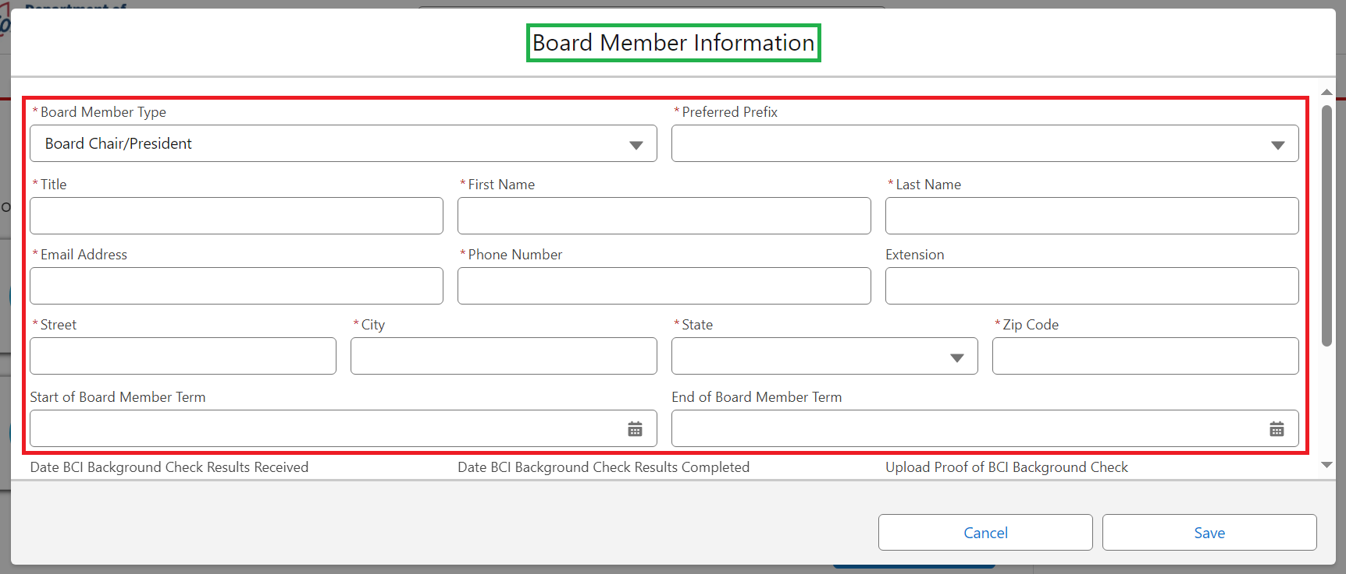

1. Select the **Dates for BCI Background Check Results Received**.
2. Select the **Dates for BCI Background Check Results Completed**.
3. Upload **Proof of the BCI Background Check** by clicking the **Upload Files** button.

**Note:** A Popup Box will display to verify the document you are uploading. Click **Done** to complete upload.

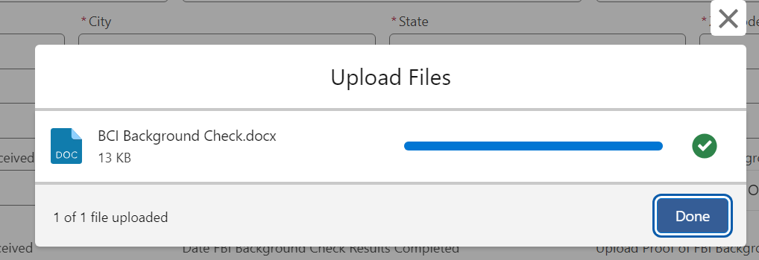

1. Select the **Dates for FBI Background Check Results Received**.
2. Select the **Dates for FBI Background Check Results Completed**.
3. Upload **Proof of FBI Background Check** by clicking the **Upload Files** button.
4. Click the **Save** button.

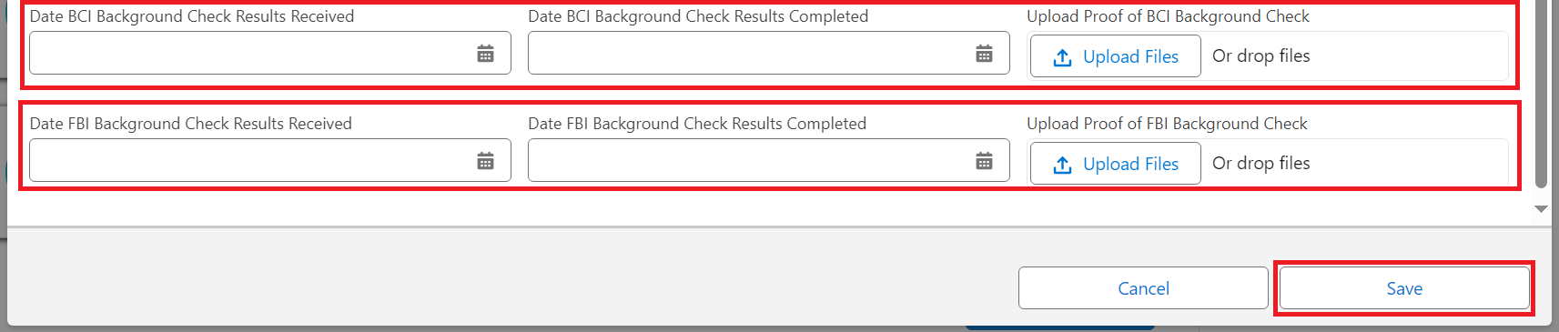

1. When done adding Members, click the **Save and Continue** button.

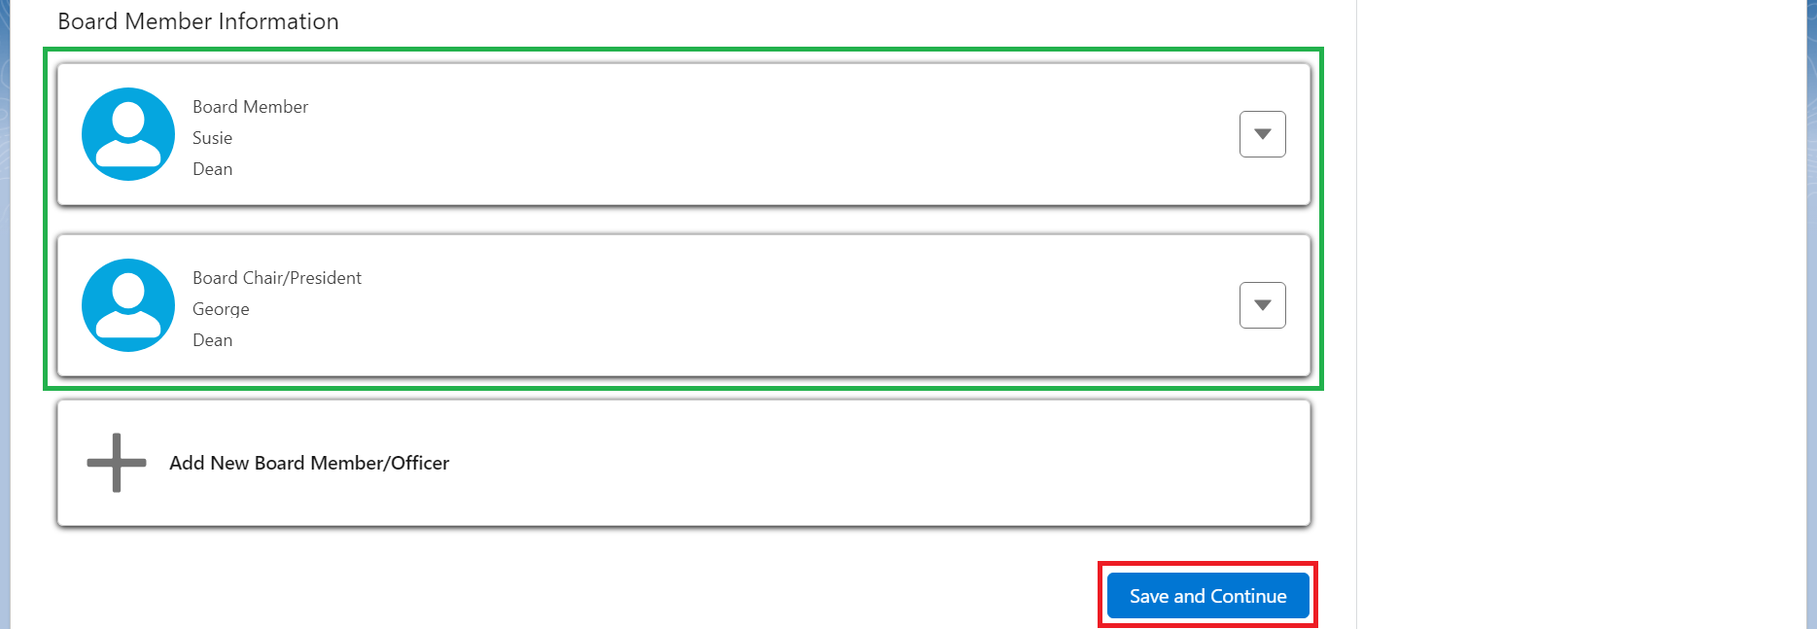

The **Functions** screen displays.

**Functions**

1. Check all the boxes identifying the **Functions** applicable to your agency,

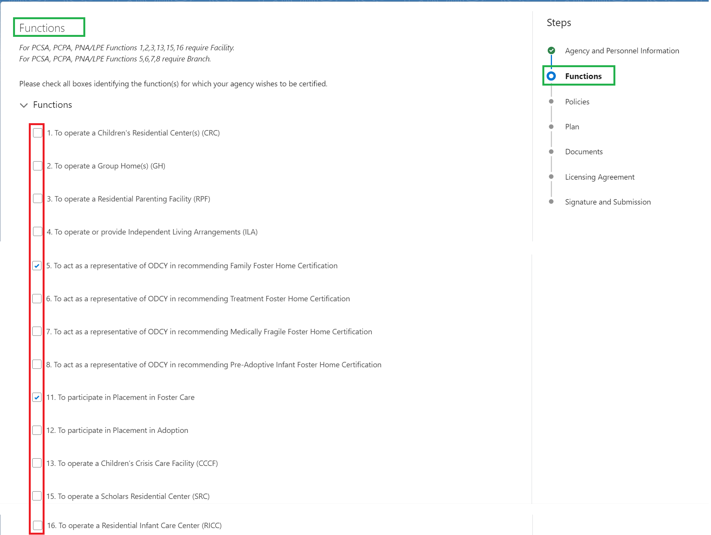

1. Select **Yes** or **No** for **Your agency will be operating from your provided Administrative Office. Do you have another office you plan to use for your agency?**

Note: If **No** was selected, the user does not need to add an additional Branch. If Yes was selected, you must add the Branch Information.

1. Click the **Add Branch** button.

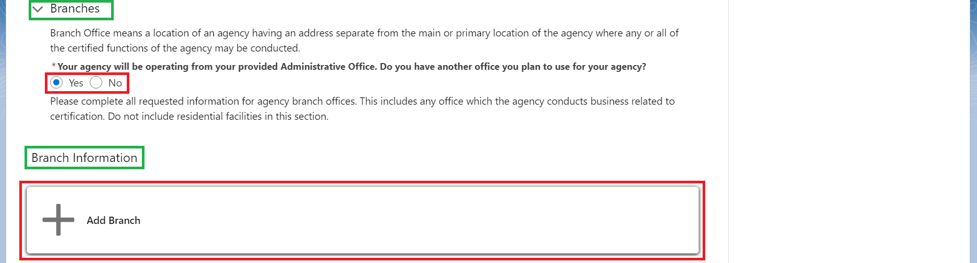

The Branch Information screen displays.

1. Provide the **Branch Name**. (Required)
2. Provide the **Branch Street Address, City, State and Zip Code**. (Required)

Note: **State** is prefilled and not editable.

1. Make a selection for **Branch County**. (Required)
2. Provide the **Branch Supervisor Name**. (Required)
3. Provide the **Branch Supervisor Title**. (Required)
4. Provide the **Branch Phone Number**. (Required)
5. Provide the **Branch Fax Number**. (Optional)
6. Click the **Save** button.

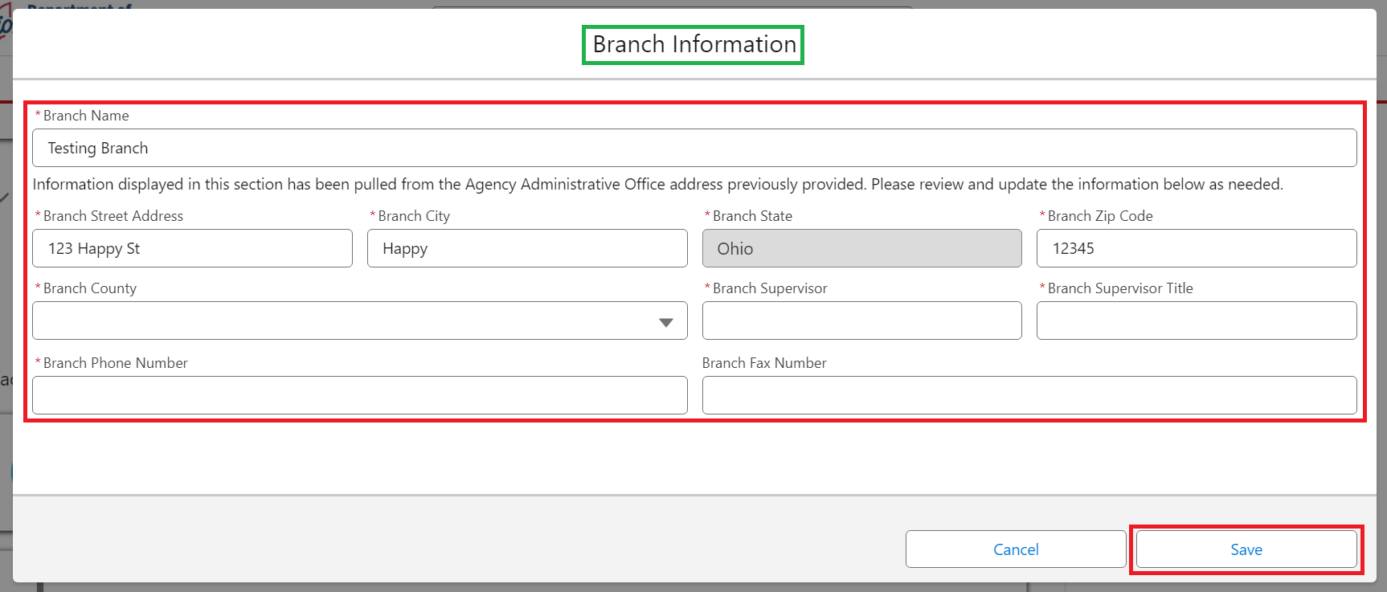

The **New Branch Information** displays.

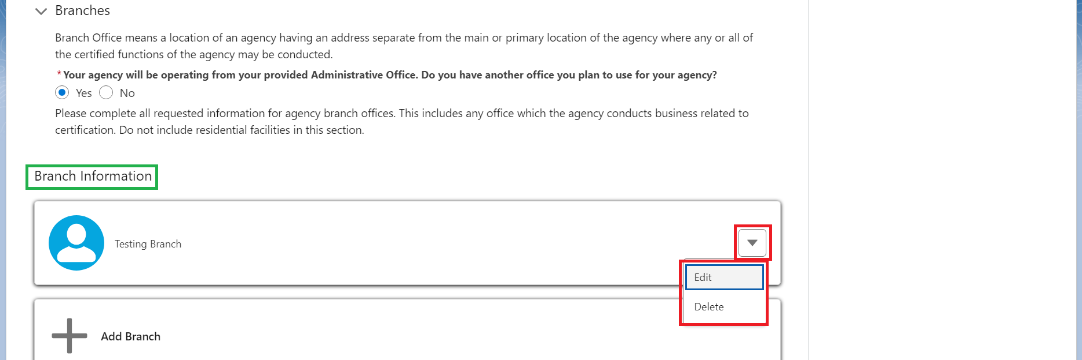

**Note:** The user can **Edit** and/or **Delete** the Branch Information by clicking the Caret dropdown, shown above.

1. Select **Yes** or **No** for, **Do you have more than one residential or group home facility at this time?**

Note: If **No** was selected, the user does not need to add additional Facility Information. If **Yes** was selected, Facility Information will need to be added.

1. Click the **Add Facility** button.

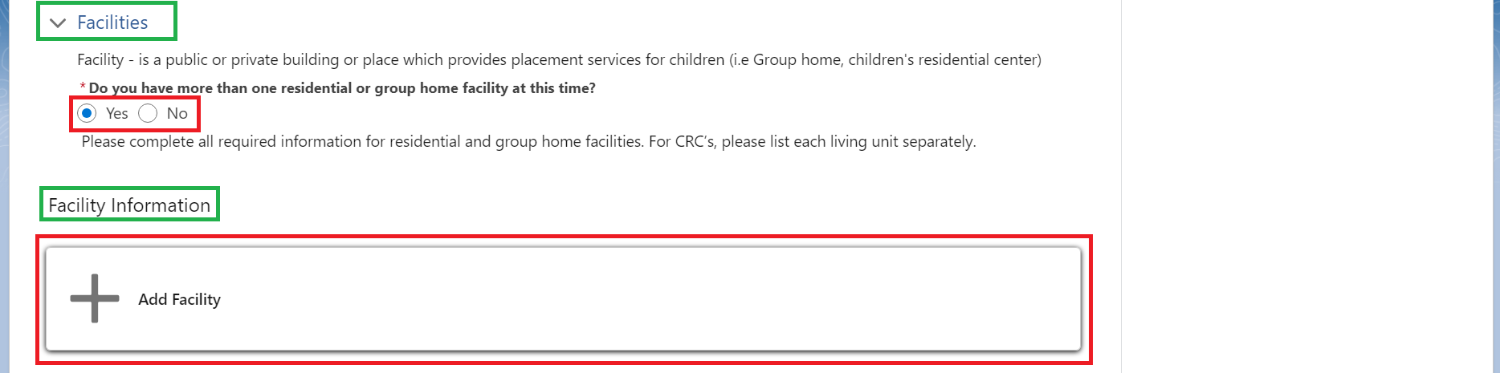

The **Facility Information** screen displays.

1. Provide the **Facility Name**. (Required)
2. Provide the **Facility Street Address, City, State and Zip Code**. (Required)

**Note:** **State** is prefilled and not editable.

1. Make a selection from the **Facility County** dropdown menu. (Required)
2. Provide the **Facility Director Name**. (Required)
3. Provide the **Facility Phone Number**. (Required)
4. Provide the **Facility Fax Number**. (Optional)
5. Make a selection from the **Facility Type** dropdown menu. (Required)

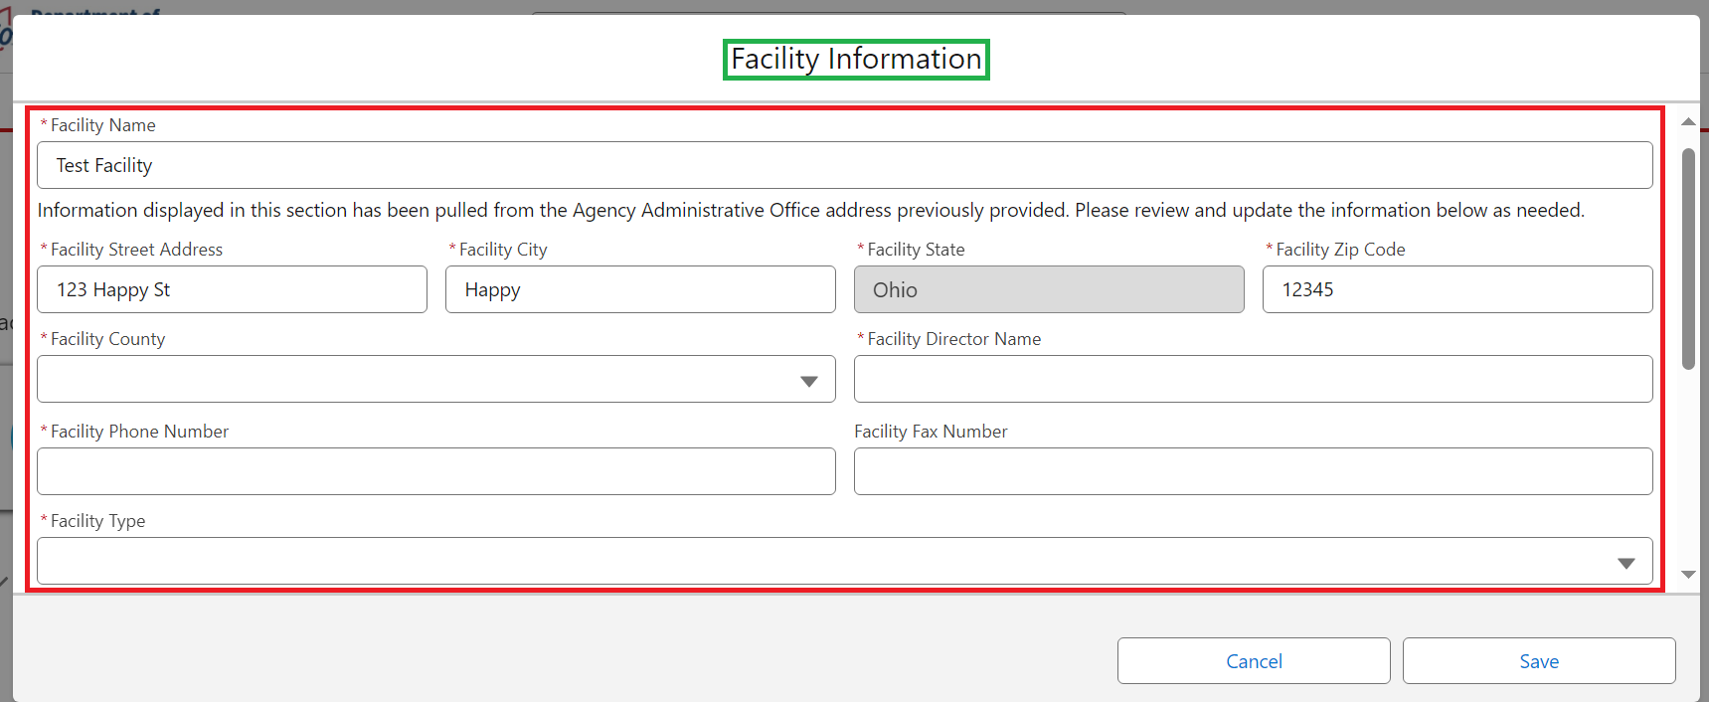

1. Provide the **Total Number of Children**. (Required)
2. Make a selection from the dropdown menu for, **Gender of Children You Plan to Serve**. (Required)
3. Make a selection from the **Minimum Age Years** dropdown menu. (Required)
4. Make a selection from the **Minimum Age Months** dropdown menu. (Required)
5. Make a selection from the **Maximum Age Years** dropdown menu. (Required)
6. Make a selection from the **Maximum Age Months** dropdown menu. (Required)
7. If applicable, checkmark the box for, **Serves mentally or physically handicapped persons under twenty-one years of age**. (Optional)
8. Click the **Save** button. (Required)

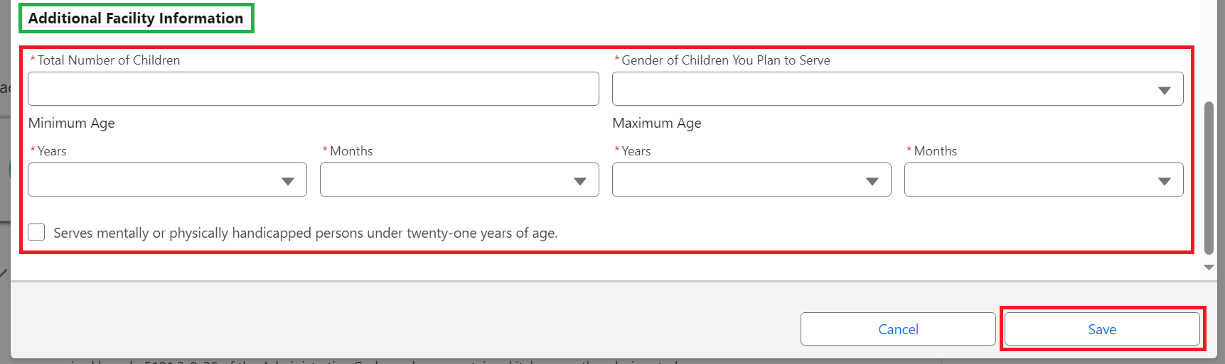

1. Select **Yes** or **No** for, **Will you have more than one living unit in this Facility**?

**Note:** If **No** was selected, the user does not need to add additional Living Units. If **Yes** was selected, the user will need to add Living Units.

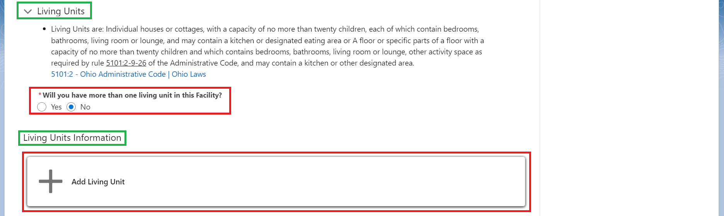

1. Click the **Add Living Unit** button.

The **Living Unit Information** screen displays.

1. Make a selection from the **Facility Name** dropdown menu.
2. Provide the **Living Unit Name**.
3. Provide the **Total Number of Children**.
4. Make a selection from the dropdown menu for **Gender of Children You Plan to Serve**.
5. Make a selection from the **Minimum Age Years** dropdown menu. (Required)
6. Make a selection from the **Minimum Age Months** dropdown menu. (Required)
7. Make a selection from the **Maximum Age Years** dropdown menu. (Required)
8. Make a selection from the **Maximum Age Months** dropdown menu. (Required)
9. Click the **Save** button.

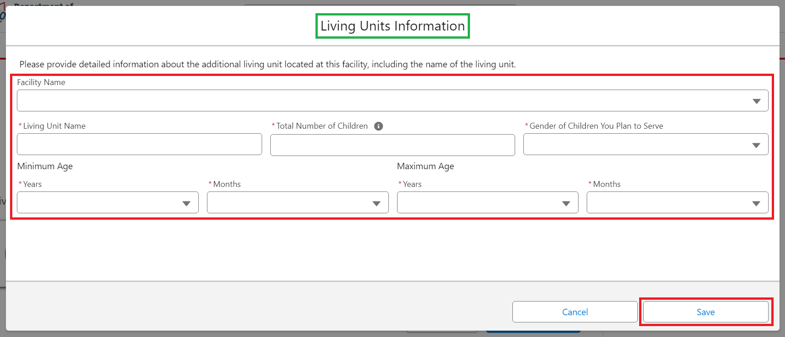

1. Click **Save and Continue**.

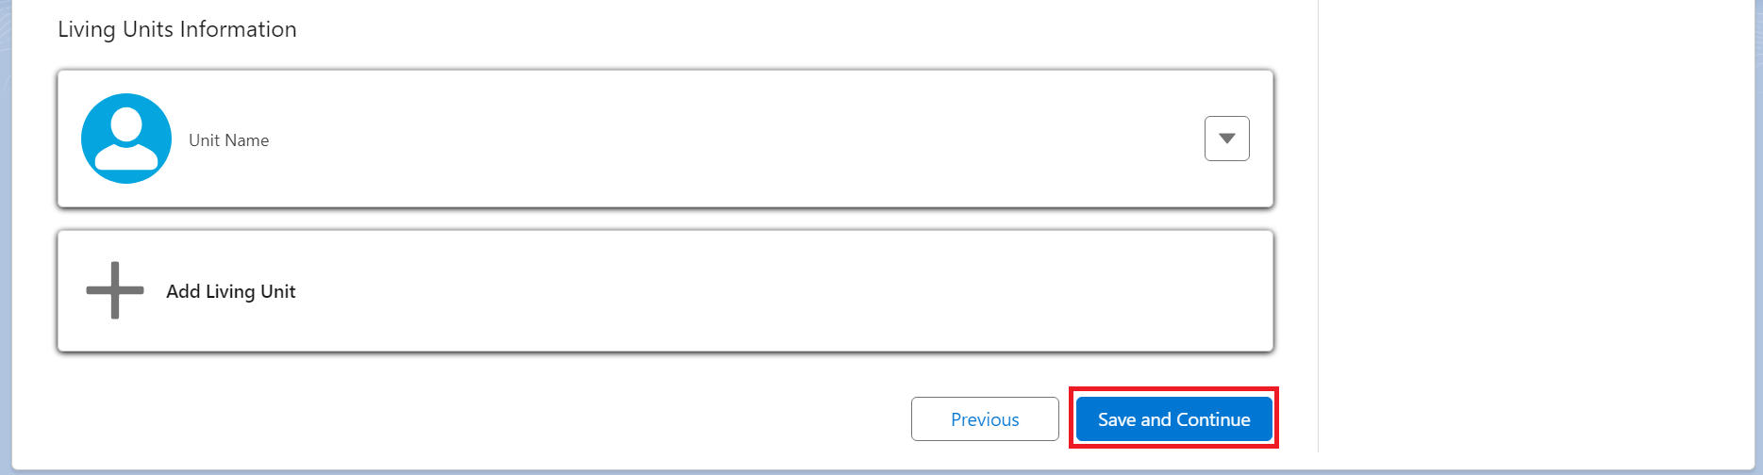

The **Policies** screen displays.

**Policies**

1. Upload required documents by clicking the **Upload Files** button for each Policy listed.

**Note:** The Policies listed are required policies for the Functions(s) the user has selected. The policies listed will be different depending on the function each user selected.

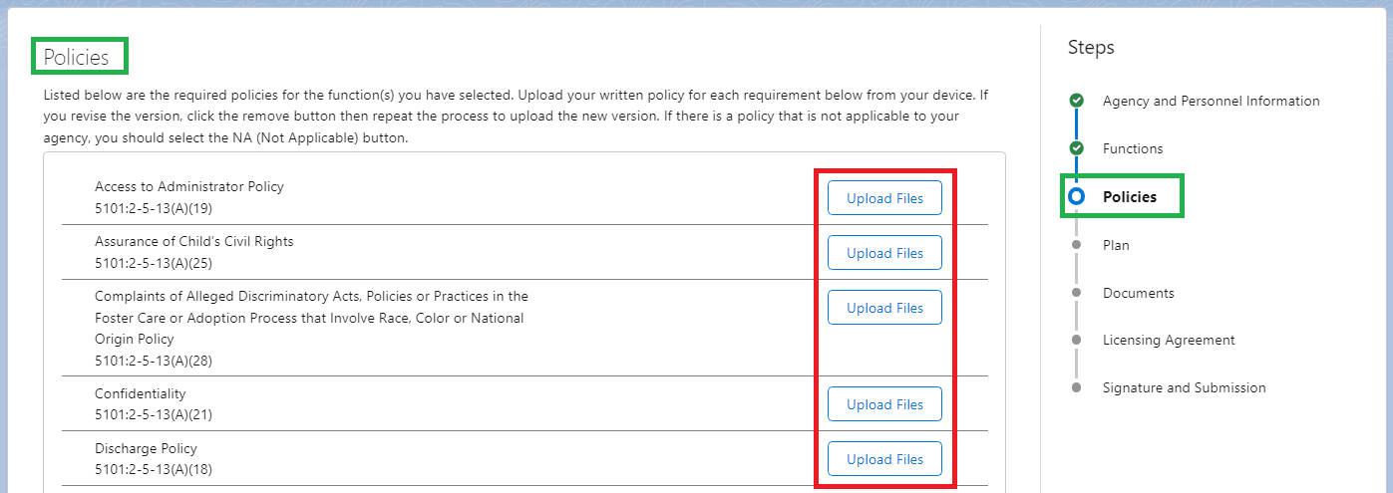

**Note:** A Popup Box will display to verify the document you are uploading. Click **Done** to complete upload.

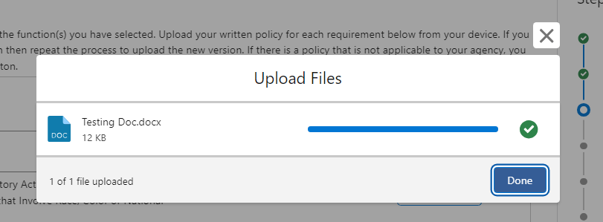

1. **Complete step #1** for each **Policy** listed.

**Note:** When a document is successfully uploaded, a green checkmark appears next to the document. See below:

1. When complete, click the **Save and Continue** button.

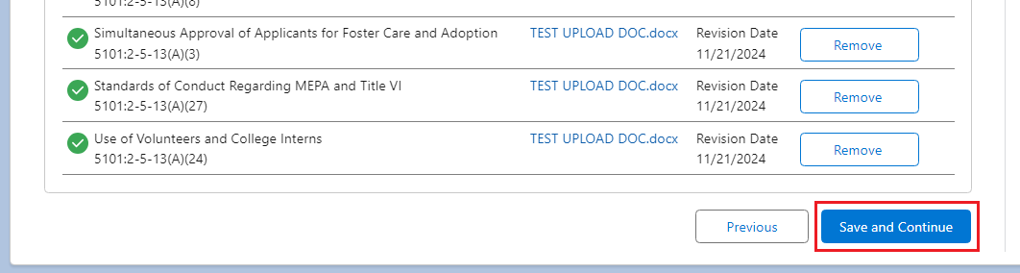

**Plan**

1. Click **Upload Files** to upload the appropriate required documents.

**Note:** The Plans listed are required plans for the Function(s) the user has selected. The plans listed will be different depending on the function each user selected.

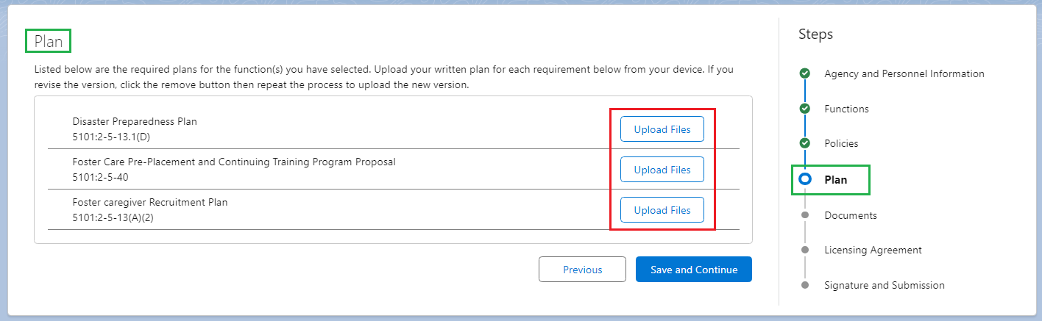

**Note:** A Popup Box will display to verify the document you are uploading. Click **Done** to complete upload.

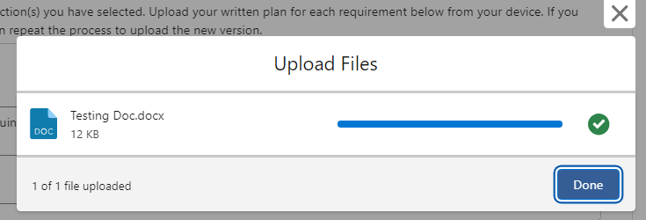

1. When complete, click the **Save and Continue** button.

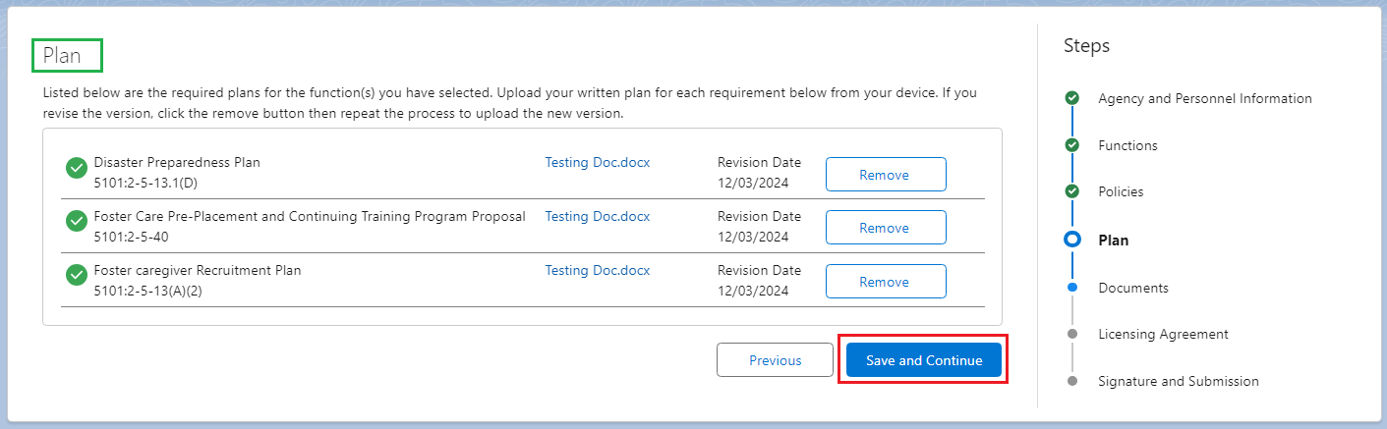

**Documents**

1. Click **Upload Files** on the appropriated required documents.

**Note:** The Documents listed are required documents for the Function(s) the user has selected. The documents listed will be different depending on the function each user selected.

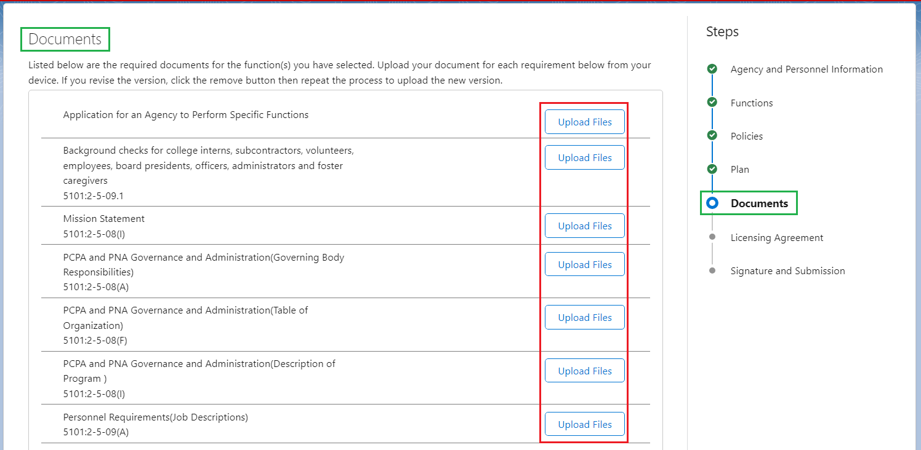

**Note:** A Popup Box will display to verify the document you are uploading. Click **Done** to complete upload.

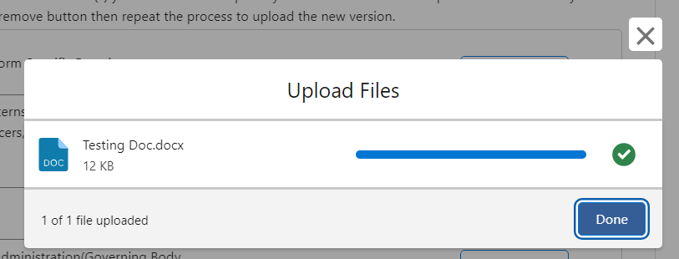

1. When complete, click the **Save and Continue** button.

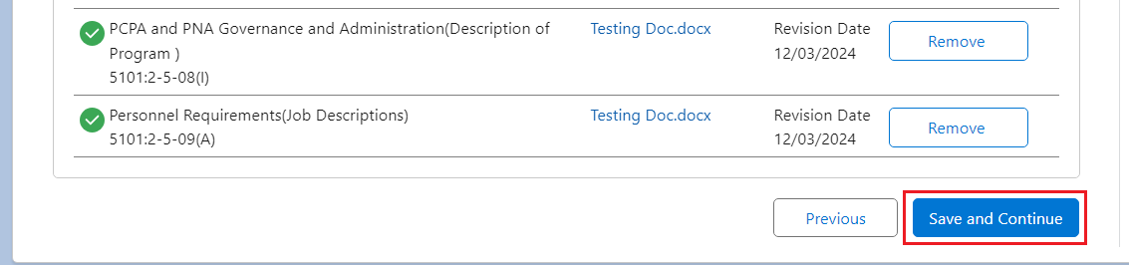

**Licensing Agreement**

1. Select **Yes** or **No** for, **Has anyone on your initial certification application ever held a license or certificate to operate a children’s residential facility, foster care or adoption agency in Ohio or any other state?** (Required)
2. If **Yes**, provide the name of the agency; name of administrator; name of agency governing body/board member(s); name of director(s); name of agency partner(s); name of agency owner(s); name of licensor entity (e.g., ODMH, State of Pennsylvania) dates of certification; and location of certified facilities or agency. (Required)
3. Select **Yes** or **No** for, **If prior history exists with another Ohio state department or out-of-state license entity, has the administrator and/or any governing body/board member(s), or director(s) as listed on the initial certification application or agency partner(s) or agency partner(s) or agency owner(s) ever had an agency license or certificate revoked or was subject to revocation, suspension or forced termination?** (Required)
4. If **Yes**, provide the name of the agency; name of administrator; name of the agency governing body/board member; name of director(s); name of agency partner(s); name of agency owner(s); licensor (e.g. ODMH, State of Pennsylvania, etc.); dates of certification, location of certified facilities or agency; and reason(s) for revocation, suspension, or forced termination. (Required)
5. Select **Yes** or **No** for, **If prior history exists with ODJFS or ODCY, has the administrator and/or any governing body/board member(s), or director(s) as listed on the initial certification application or agency partner(s) or agency owner(s) ever been named a principal in an adjudication order for the denial of an initial certification or revocation of an existing license?** (Required)
6. If **Yes,** provide the name of the agency; name of administrator; name of the agency governing body/board member(s); name of director(s); name of agency partner(s); name of agency owner(s), who were named as a principle in the adjudication order; dates of certification; location of certified facilities or agency; reason(s) for denial or revocation, date when the 5 year ban expires. (Required)

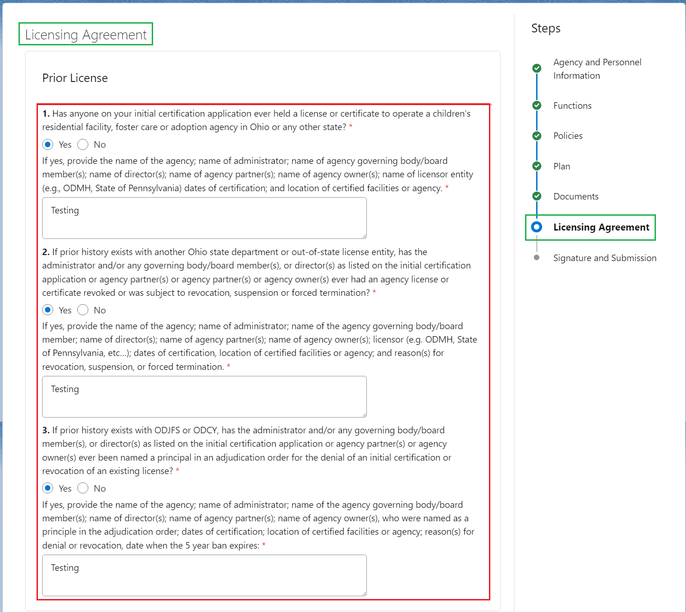

1. Review the **Affirmation and Assurance** section.
2. **Checkmark** the box for, **As the Agency Administrator, I do acknowledge and assure the above affirmations and assurances**. (Required)

**Note:** The Board President checkmark box is not editable. The Board President will login separately to complete this portion of the application.

1. Click the **Save and Continue** button.

**Note:** The checkboxes are mandatory prior to submission but not to move forward to the next screen.

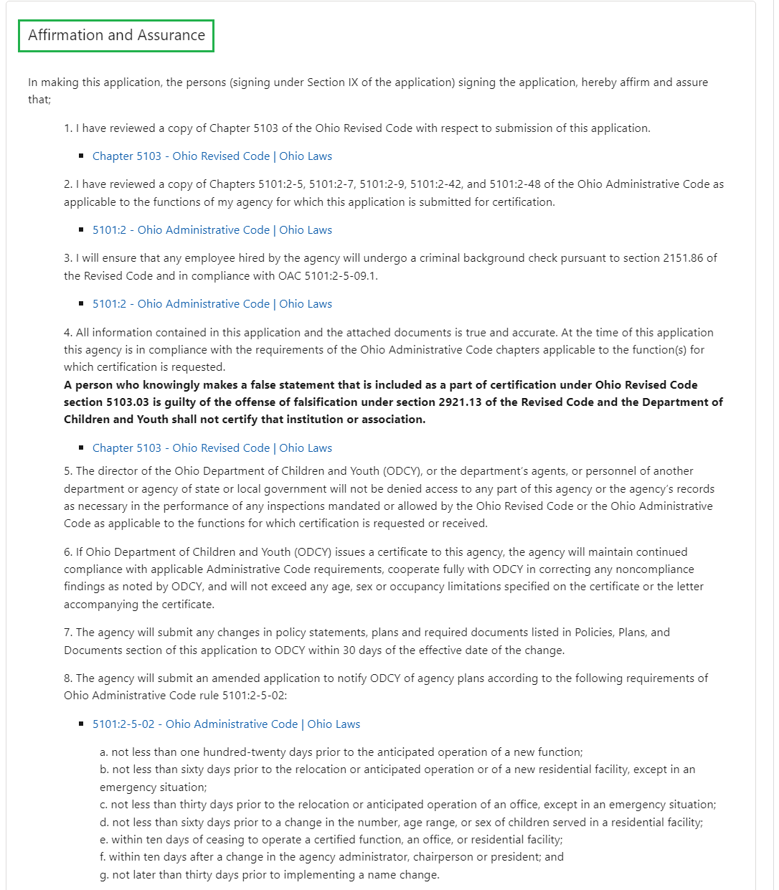

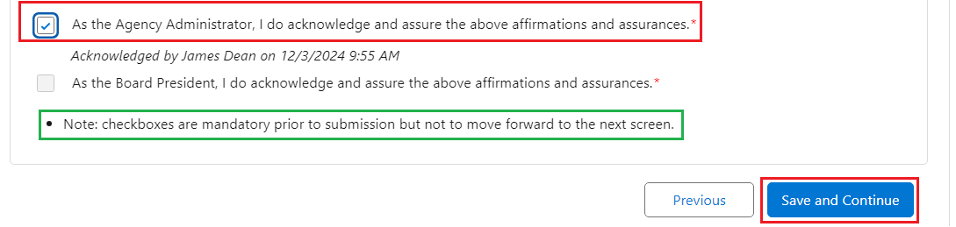

**Signature and Submission**

Before signing, review all affirmations and assurances for important information. Be sure the entire application is complete. An application is not considered complete until all required policies, plans, and other documents required by applicable Ohio Administrative Code rules pertaining to an agency’s certified function(s) have been submitted to ODCY.

**Note:** The application cannot be submitted until the **Board President** also signs the application. For the purpose of this User Guide, it will review the process of the Board President’s needed signature and the Board President submission of the application.

1. Agency Administrator, **Sign the application**.
2. Click **Save Signature**.
3. Click **Submit**.

**Note:** The Board President’s signature is not editable.

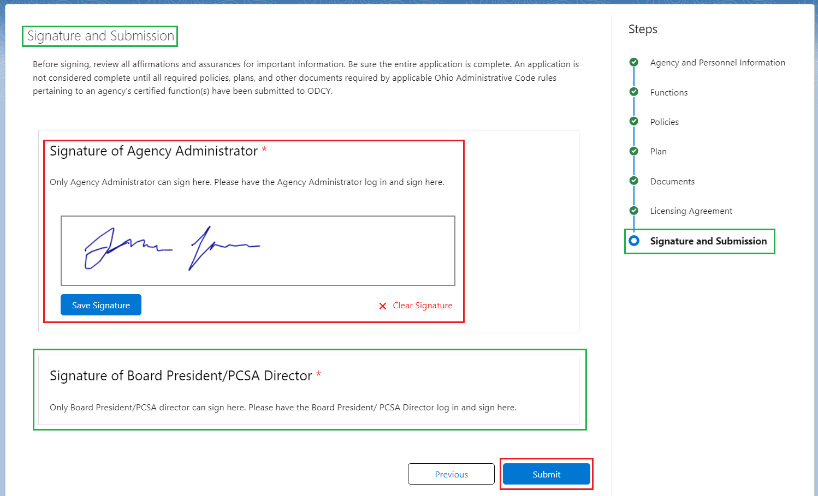

A message displays alerting the user that the **Board President** must acknowledge and assure the affirmations and assurances as well as sign the application.

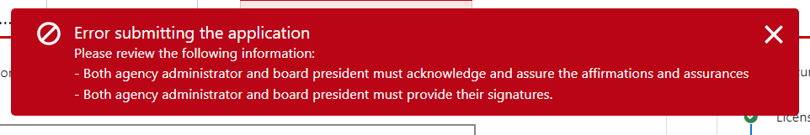

**Board President Signature and Application Submission**

To review how a Board President accesses OCAF and reviews the application, please refer to this User Guide: (insert link when completed)

1. From the **Licensing Agreement** screen, checkmark the box for **As the Board President I do acknowledge and assure the above affirmations and assurances**. (Required)
2. Click **Save and Continue**.

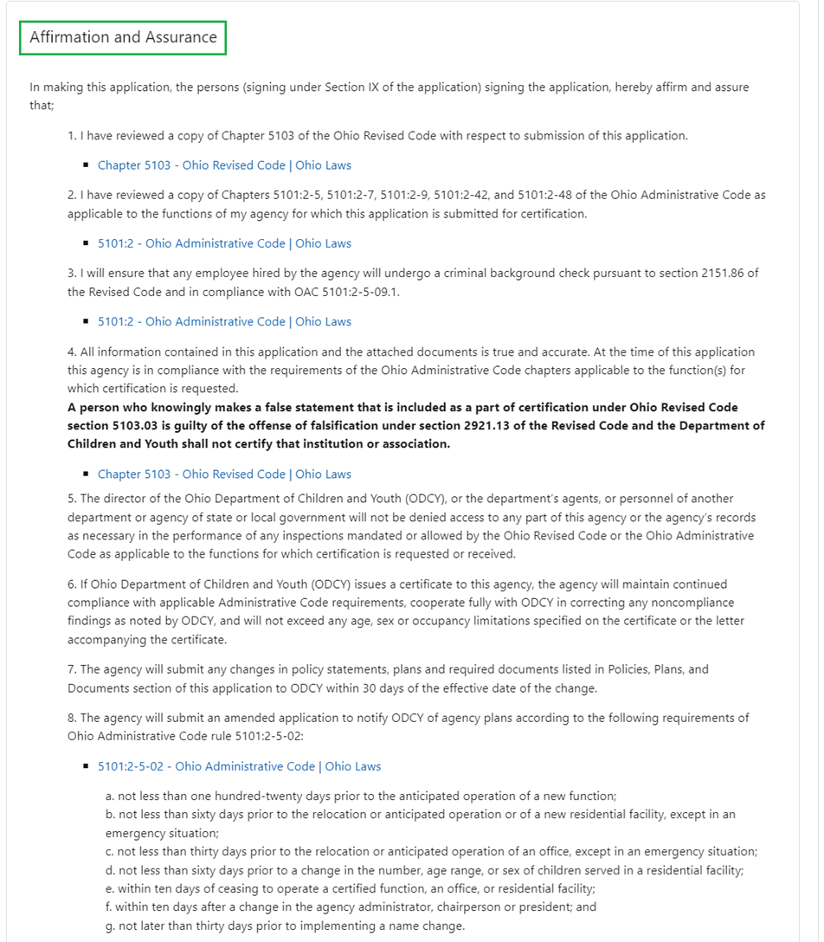

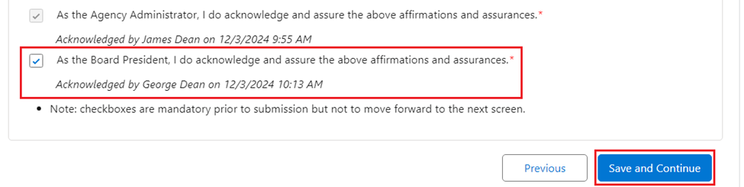

The **Signatures and Submission** screen displays.

1. Board President, **Sign the Application**.
2. Click **Save Signature**.

**Note:** The **Save Signature** button disappears when clicked. It will then display the Name, Date and Time the signature was saved as shown below.

1. Click the **Submit** button.

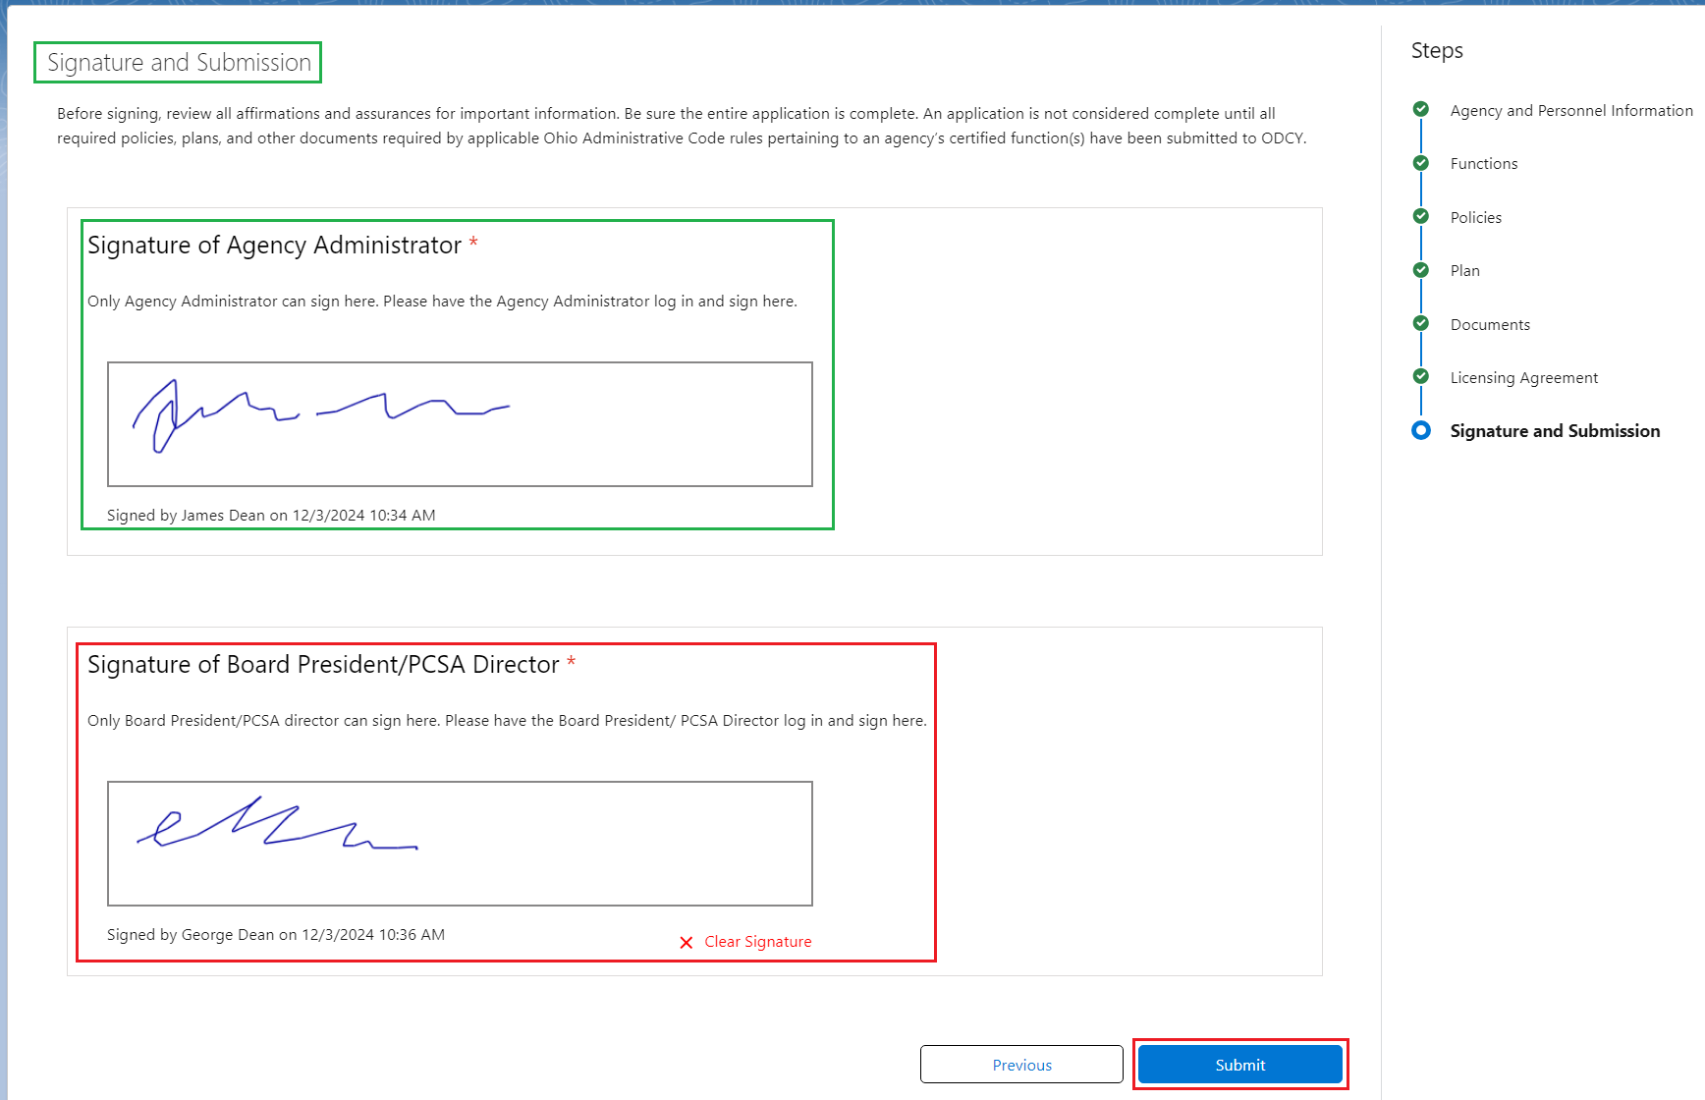

A message displays verifying the application was submitted.



From the **OCAF Home** tab, the Initial Certification Application shows as **Submitted**.

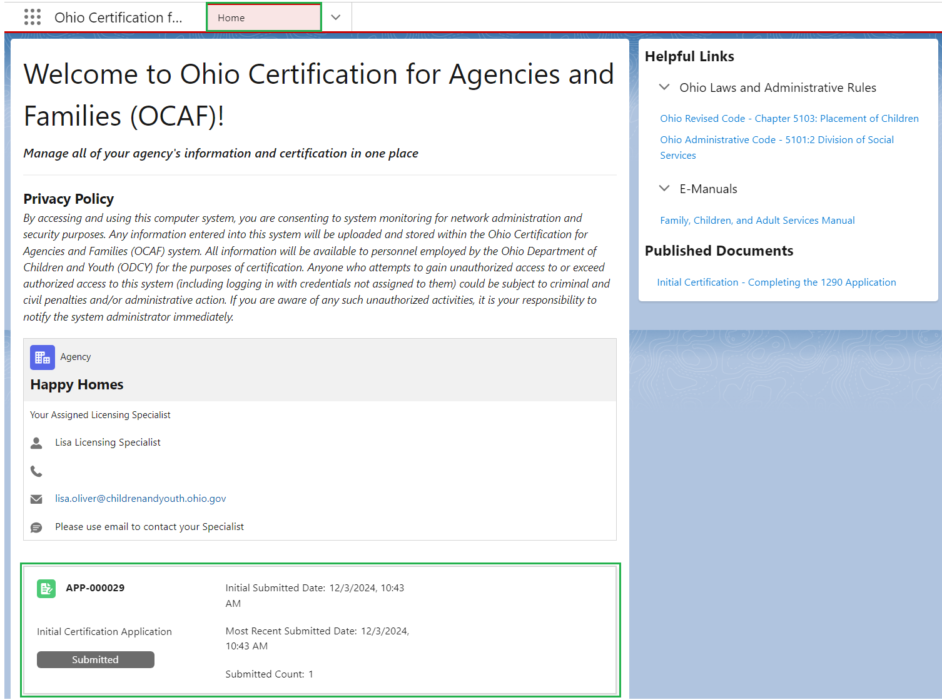

If you have additional questions pertaining to this Deployment Communication, please contact the [Customer Care Center](https://gcc02.safelinks.protection.outlook.com/?url=https%3A%2F%2Fodjfs2.my.site.com%2FCustomerCareCenter&data=05%7C02%7CLisa.Oliver2%40jfs.ohio.gov%7C989cf850d37046f616fb08dc62ce48c2%7C50f8fcc494d84f0784eb36ed57c7c8a2%7C0%7C0%7C638493885340155072%7CUnknown%7CTWFpbGZsb3d8eyJWIjoiMC4wLjAwMDAiLCJQIjoiV2luMzIiLCJBTiI6Ik1haWwiLCJXVCI6Mn0%3D%7C0%7C%7C%7C&sdata=m7Jj%2FJgZoByjWSmS1yVsBvkU74K5cBrLFP0FC1bFFvo%3D&reserved=0).